Airport Project Report

Implementation by Circular Queue

2012142031 정지승

Introduction

The project was to simulate an airport with 5 runways, a queue of planes awaiting takeoff and a queue of planes awaiting landing. For each time sequence planes would arrive at the airport and add their ID to the landing queue. As each time sequence passes the planes waiting in the landing queue lose fuel by 1. In the process if a plane’s fuel becomes 0 it is classified as an emergency and is given priority to land as quickly as possible. Also for each time sequence planes get ready for takeoff and add their ID to the takeoff queue. Both landing queues and takeoff queues can access the runway in similar manner except for the 5th runway. The 5th runway is given priority to takeoff except for an emergency landing. Each runway can be loaded 1 plane at a time. The loaded planes then exit the runway also one at a time. Therefore the runways rarely exceed their capacity. On the other hand, for the landing and takeoff queues, planes are added with probabilities following the Poisson and uniform distribution respectively. The Poisson distribution is as follows:

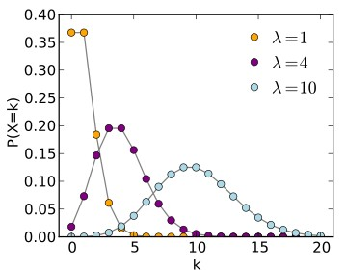

***Probability mass function of the Poisson distribution***



When the Poisson distribution parameter lambda increases, so does the probability of many planes arriving at the landing queue. This results in catastrophic failure as emergencies increase. More on this issue is covered in the discussion section.

Implementation

The simulation consists of a group of circular queues: a landing queue, a takeoff queue, an emergency queue and 5 runway queues.

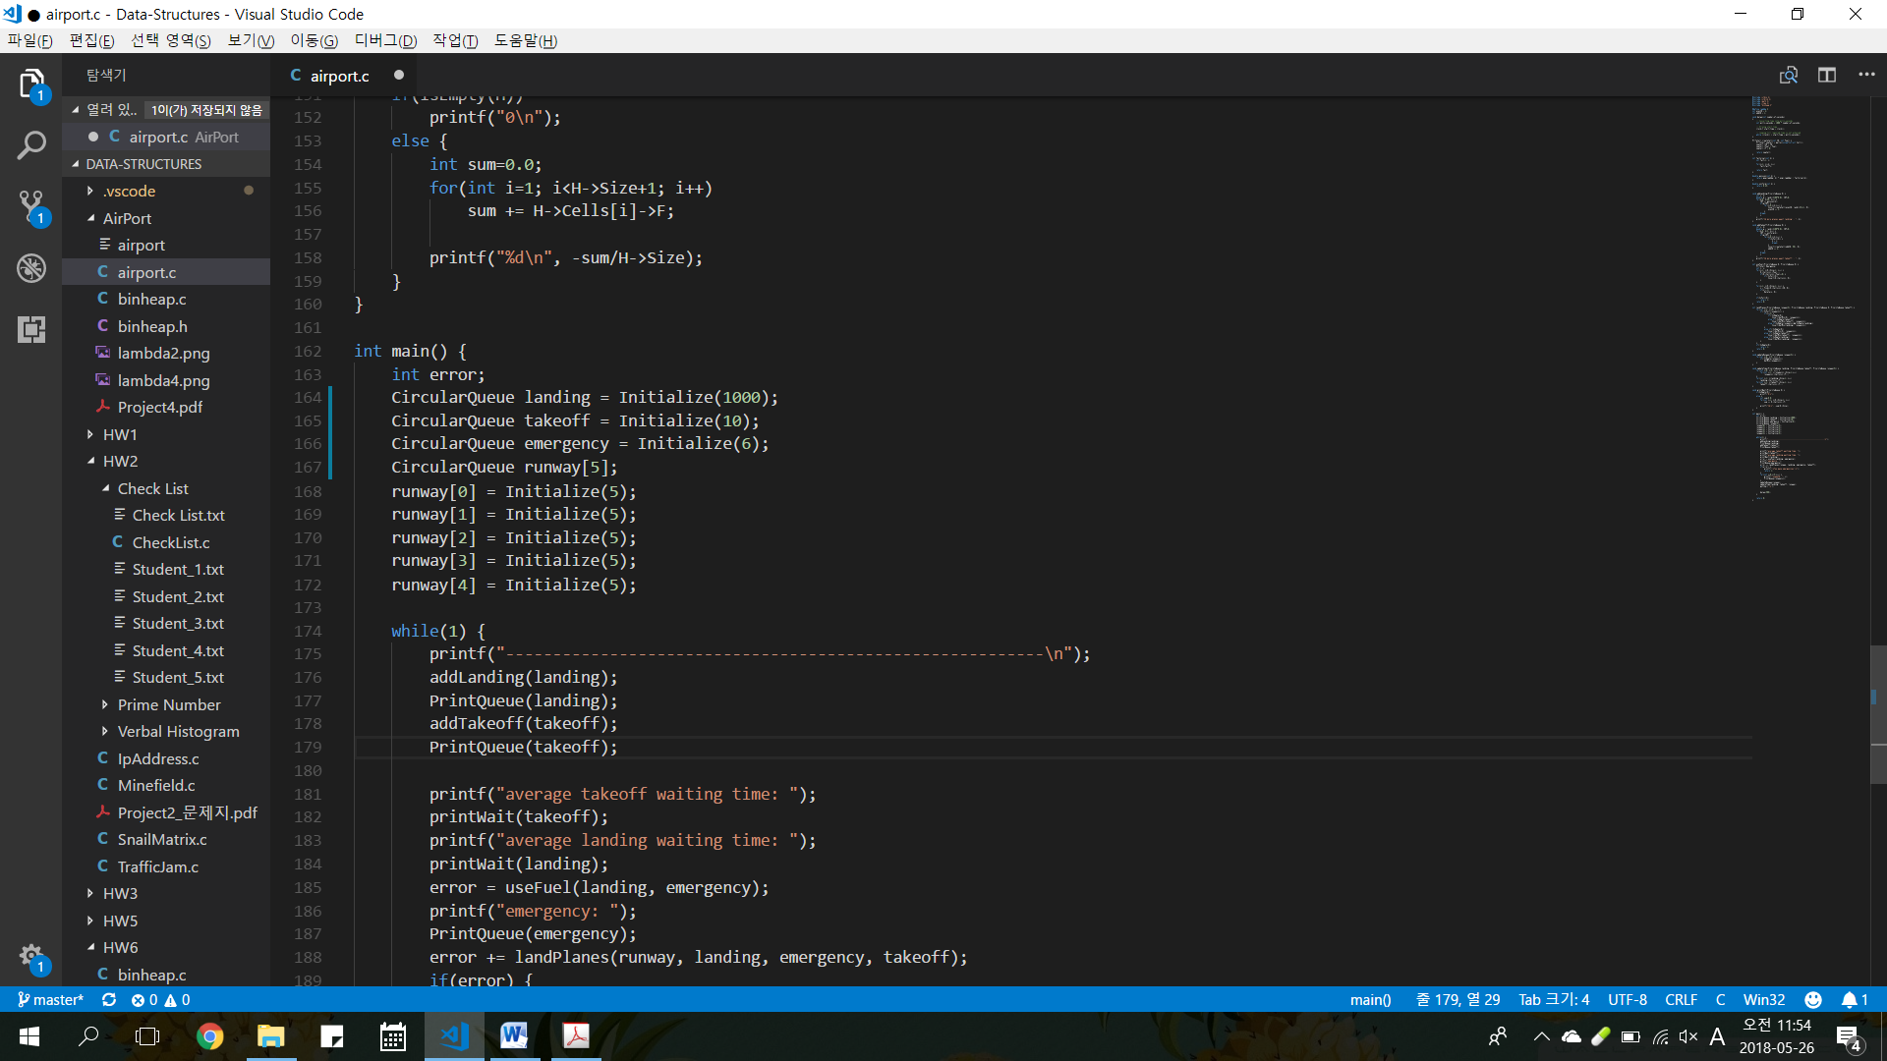

In order to keep the takeoff queue at a reasonable size I initialized the queue at a size 10. The landing queue is given a large enough size since we are not in control of arriving planes. Also I wanted to simulate a catastrophic failure where planes arrive at a very high rate. Emergencies can only be taken care of 5 at a time due to the number of runways. The reason for size 6 is to catch failures. This will be explained in detail later.

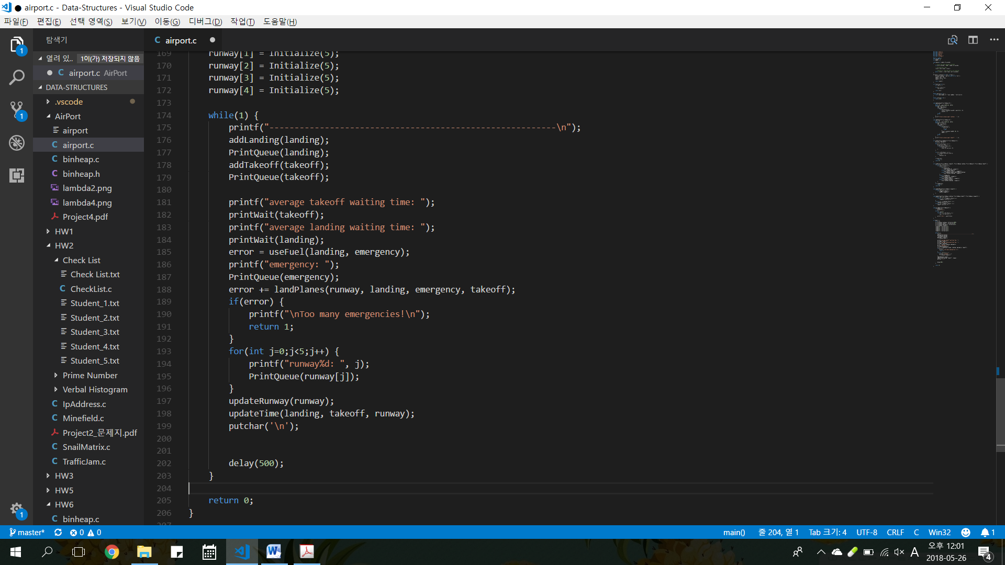

The full implementation in the main function is shown above. First we add arriving planes to the landing queue and ready planes to the takeoff queue. Next fuel of waiting planes is decreased by 1. Here if a plane’s fuel reaches zero it is transferred to the emergency queue. Finally, we move planes around in the landPlanes() function giving priority to the emergency planes. If however we fail to process all of the emergencies we exit the simulation with an error.

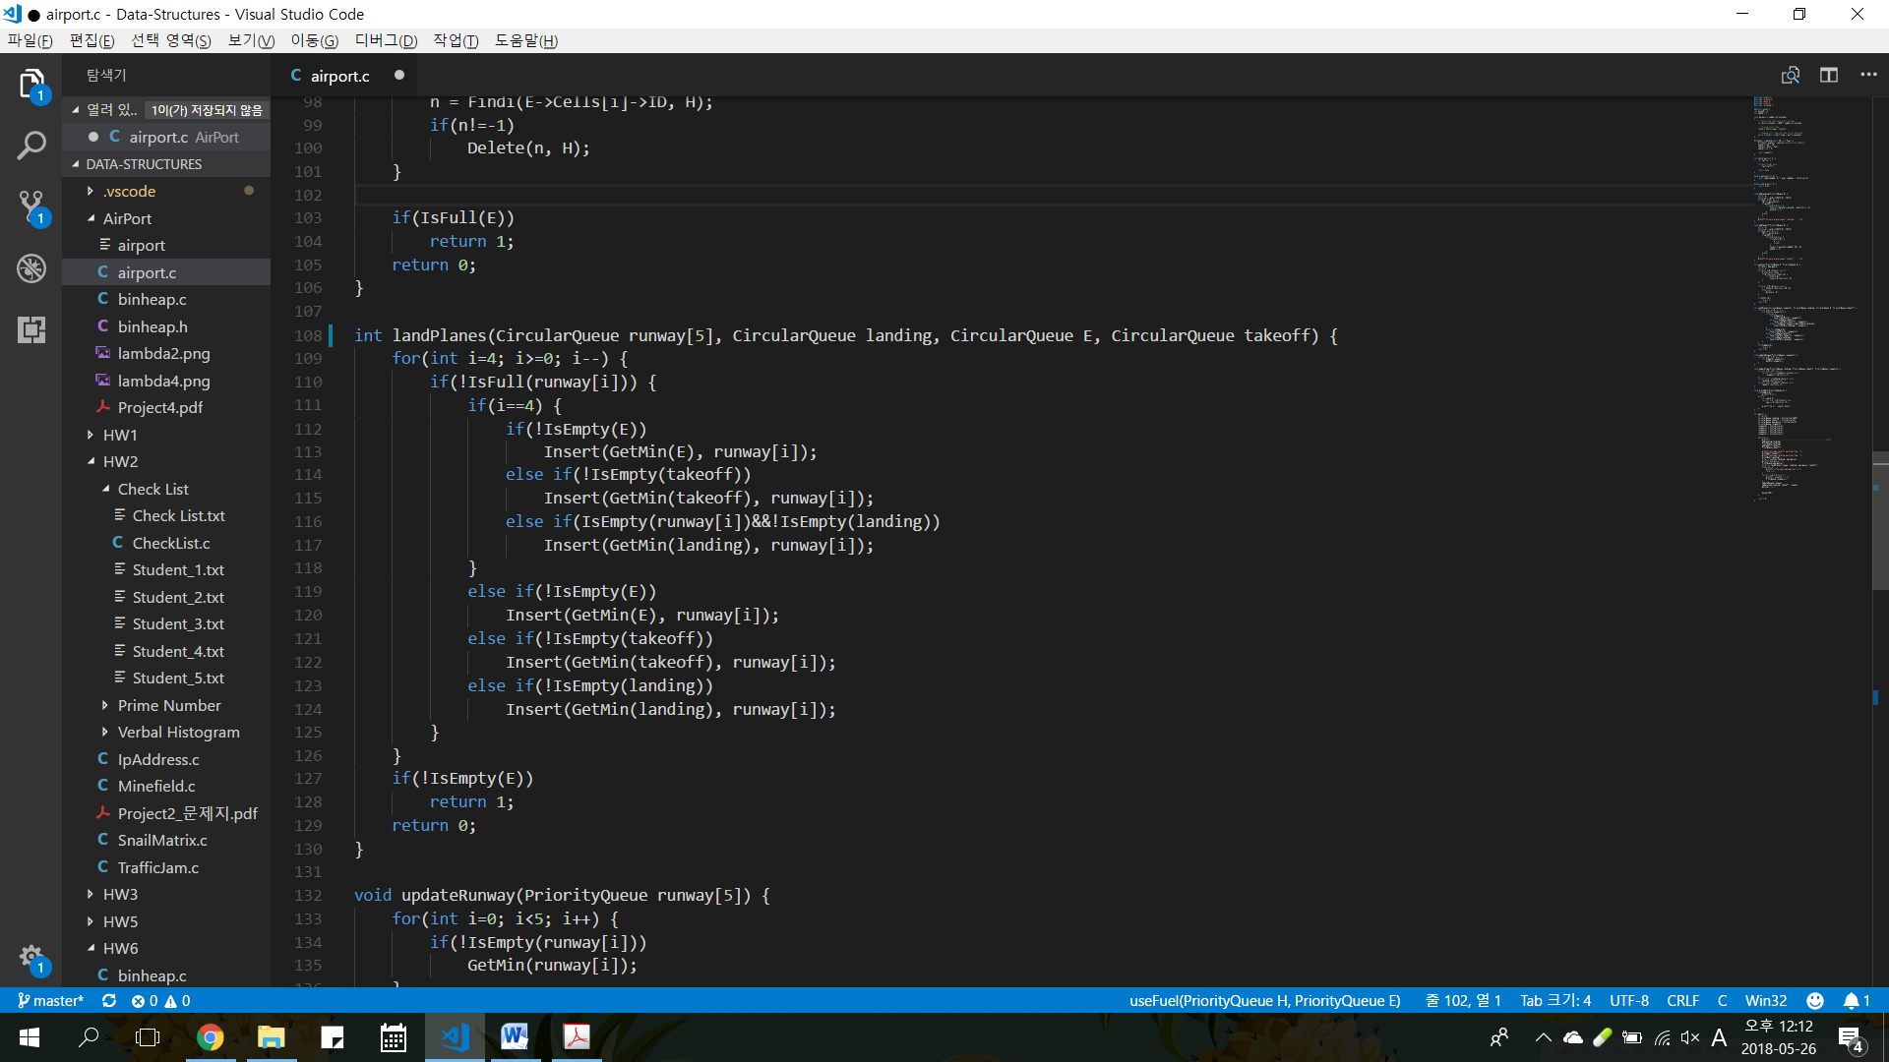

Result

This is the output of the first 5 time sequences when lambda is set to 2. There is at most 4 planes added to the landing queue each time sequence which is smaller than the number of runways. Therefore we do not run into any problems in this setting. When emergencies emerge we process them into the 5th runway. When there are multiple emergencies other runways are used also used. The average landing waiting time is 0 which means that planes are immediately able to land.

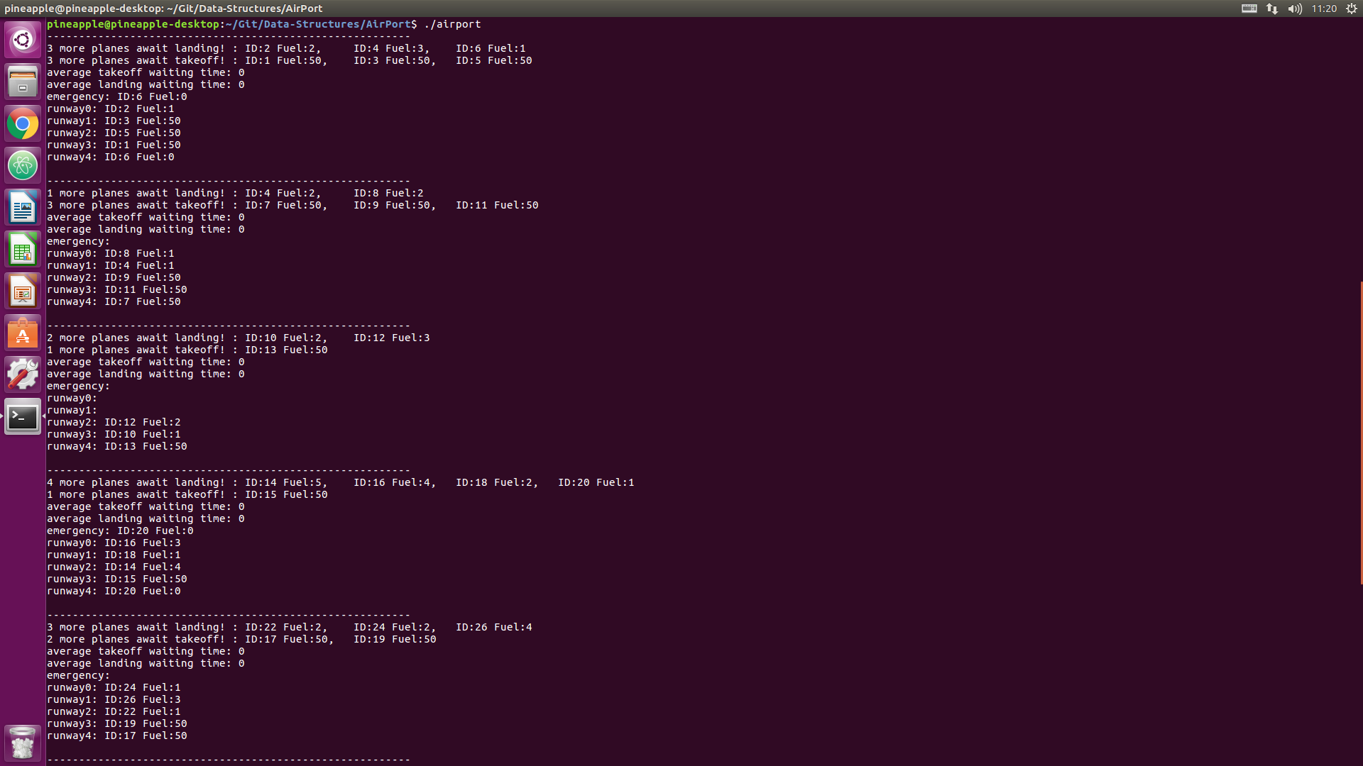

This is not the case however when lambda is set to 4(next page). Now up to 9 planes are added at each time sequence. This results in the landing queue to increase substantially. As you can see the average landing waiting time is increased to around 5 time sequences before too many emergencies emerge and the system terminates.

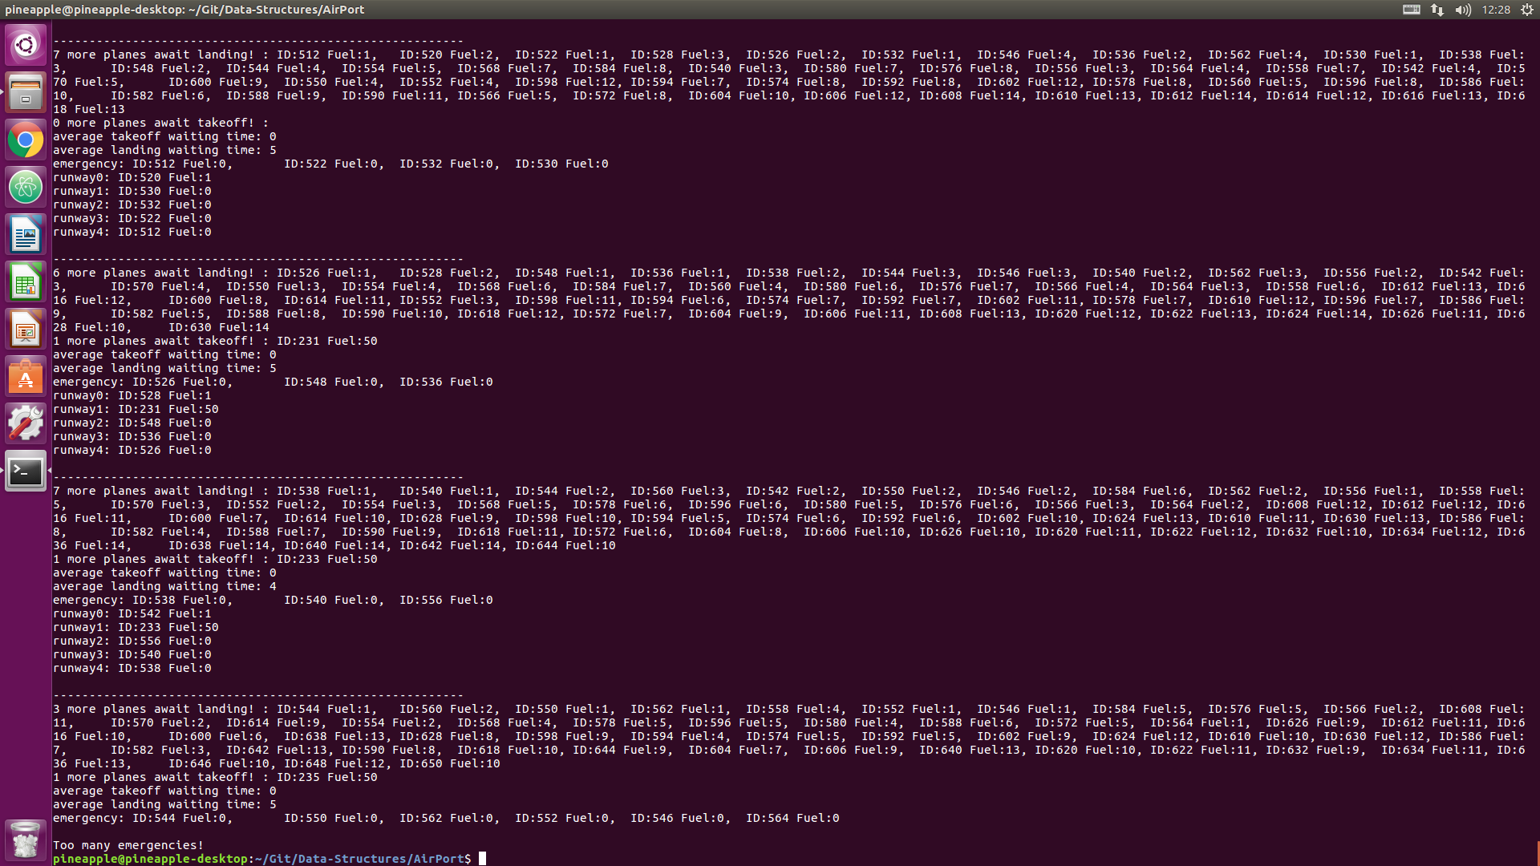

Discussion

My simulation works fine when lambda is set to a small number and the frequency of arriving planes is low. However a catastrophic failure occurs when lambda is increased. The landing queue grows substantially overtime and the waiting planes exhaust fuel causing many emergencies. Since the runways can only process 5 planes at a time more than 6 emergencies results in a plane crash. This is why the emergency queue size is set to 6. When the queue is full then we know that we have failed and the system is terminated.

A better implementation would be to have more planes land in one time sequence. Currently the runways are not well utilized. Although the size of a runway is 5 since only 1 plane can enter a runway at each time sequence the plane immediately exits the queue after that sequence is over. In reality planes are landed much faster than takeoffs especially for a busy airport. If more planes were to land in one time sequence then more planes would be on the runway and less planes would be in the landing queue.